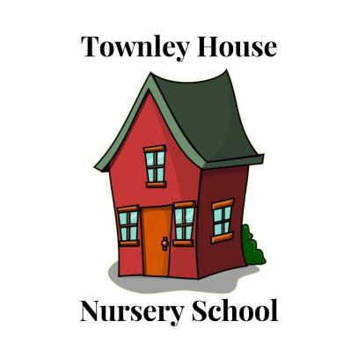

Townley House Nursery School

60 Wateringpool Lane,

Lostock Hall,

Preston,

PR5 5UA

01772 510499

townleyhousenurseryschool@hotmail.co.uk

January 2025

We have had a very busy few weeks back after the Christmas period and all the children are really enjoying our ‘Fairytale’ topic this month. We have had some excellent enhancements to support all seven areas of learning.

**Beauty and the Beast**

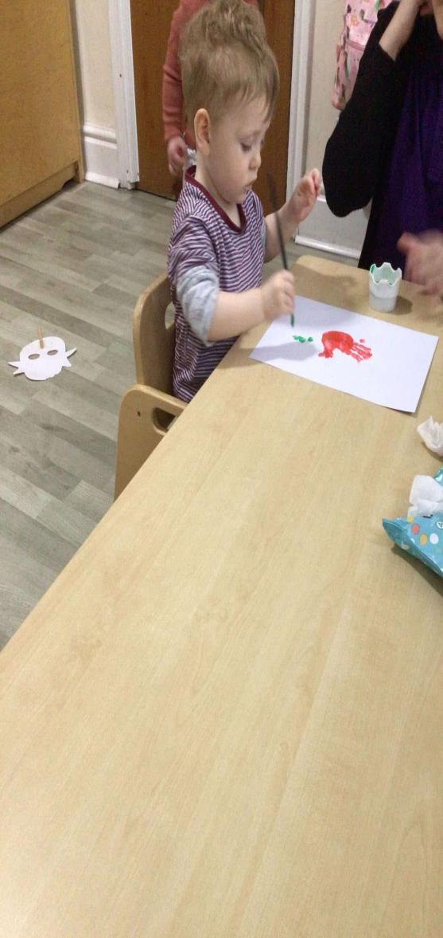 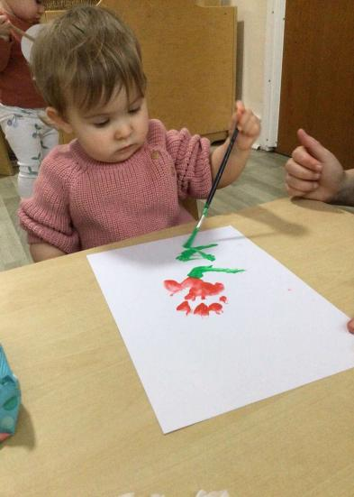 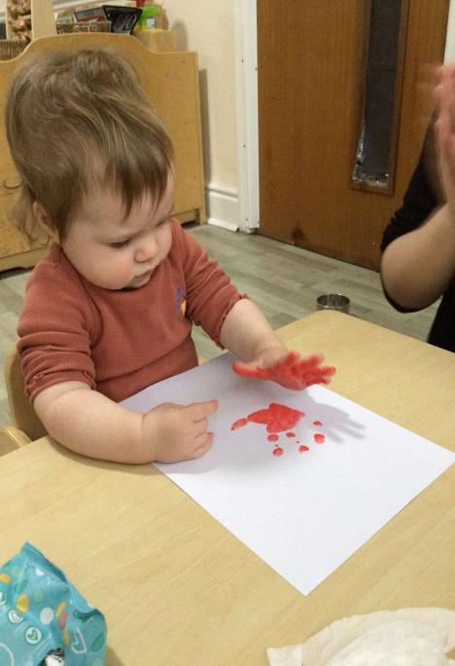

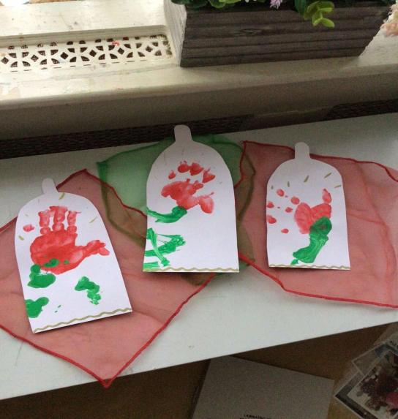

**The Three Little Pigs**

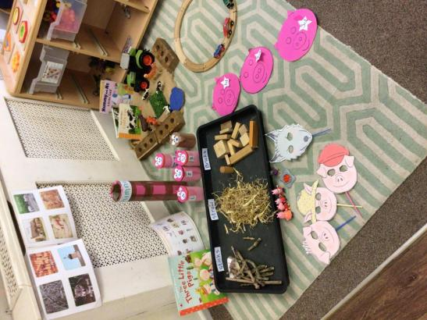 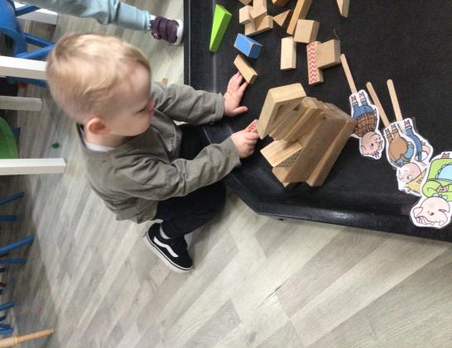 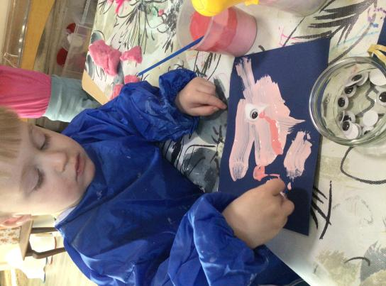

**The Gingerbread Man**

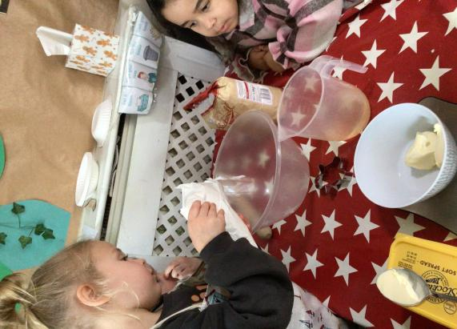 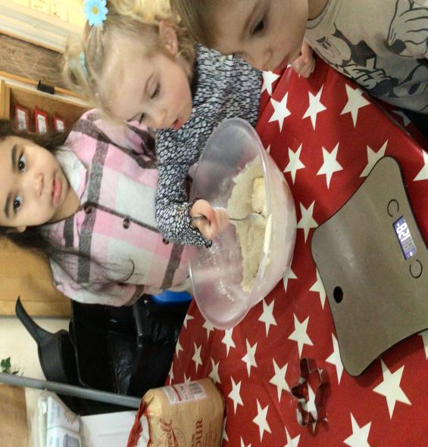 

**Goldilocks and the Three Bears**

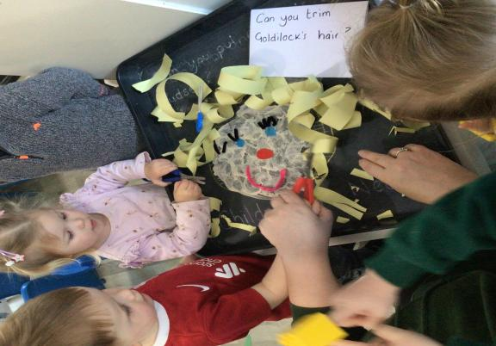 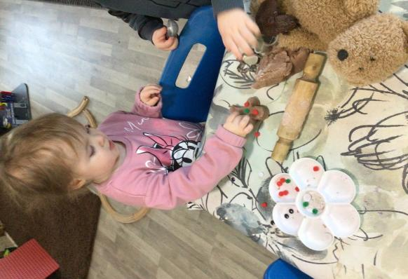 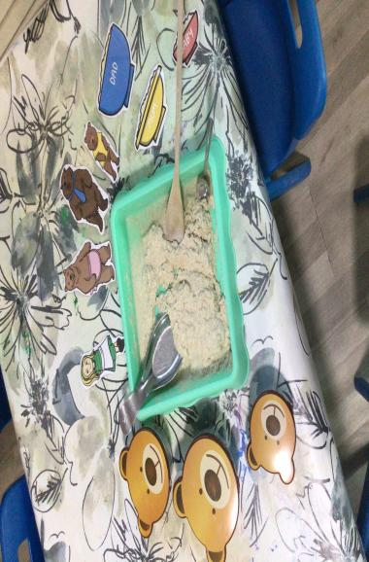

**Jack and the Beanstalk**

 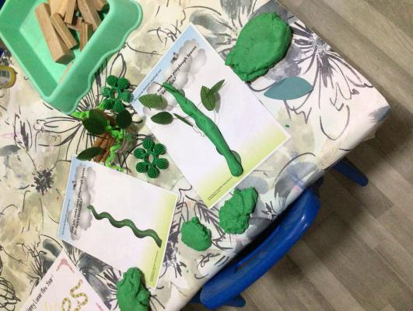 

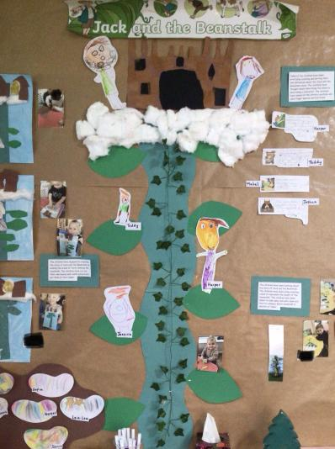 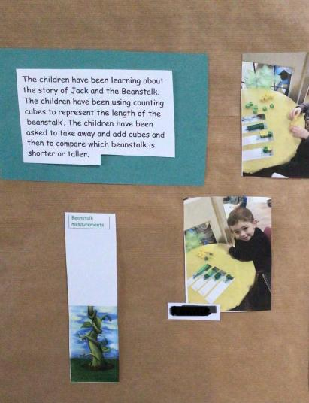 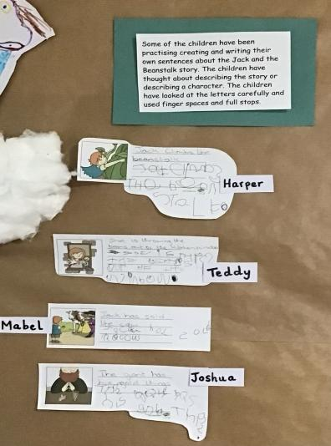

**Topics and Celebrations this Term**

Jan- Winter/Fairytales

29th January- Chinese New Year

Feb- Our 5 Senses

14th February- Valentines Day

Mar- Spring/Nature

1st March- St Davids Day

4th March- Shrove Tuesday

17th March- St Patricks Day

30th March- Mothers Day

**Term Dates for 2025**

**Spring Term**

Monday 6th January- Friday 14th February 2025

Half Term

Monday 24th February- Friday 4th April 2025

Easter Half Term

**Summer Term**

Tuesday 22nd April- Friday 23rd May 2025

Half Term

Monday 2nd June- Friday 18th July 2025

**Autumn Term**

Monday 8th September- Friday 24th October 2025

Half Term

Monday 3rd November- Friday 19th December 2025

**15/30hr Funded hours**

At the moment working parents with children aged 9mths plus, may be entitled to 15hrs funded childcare (30hrs if your child is aged 3 years and over, and or/if your child is of working parents).

However, from September 2025 **ALL** children of working parents aged 9mths plus may be entitled to 30hrs funded childcare.

**ALL** children aged 3 years plus are entitled to 15hrs universal funding the term after their 3rd birthday.

For further information click on the link below;

<https://www.childcarechoices.gov.uk/>

**Tax Free Childcare** can be used alongside the government funded hours.

**Fee increase**

With the National Living Wage increasing in April we will be increasing the nursery fees on April 1st 2025.

With funding being available for an increasing number of children, we hope the financial impact for all parents/carers will be kept to a minimum.

More information will be available by the 31st January 2025.

 Join us on Friday 14th February to celebrate surrounded by love. Enjoy some delicious treats and a chance to have a relaxed session at the Townley House cafe. Everyday should be a reason to celebrate love, so why not join us for a cup of tea, some cakes and some time to do some lovely crafts with your child/ren. Listen to some relaxing music and wind down whilst you are treated by the lovely staff at Townley House Nursery. Our cupcakes are absolutely delicious - remember, the secret ingredient is always love!

Please book a session of your choice with one of the staff at Townley House Nursery. Friday 14th February slots:

10:00-10:45AM

11:00-11:45AM

2:00-2:45PM

3:15-4:00PM

Times may vary depending on availability.